ARTS + THE CITY
Brief: Connecting Cities through Arts and Creative Exchange

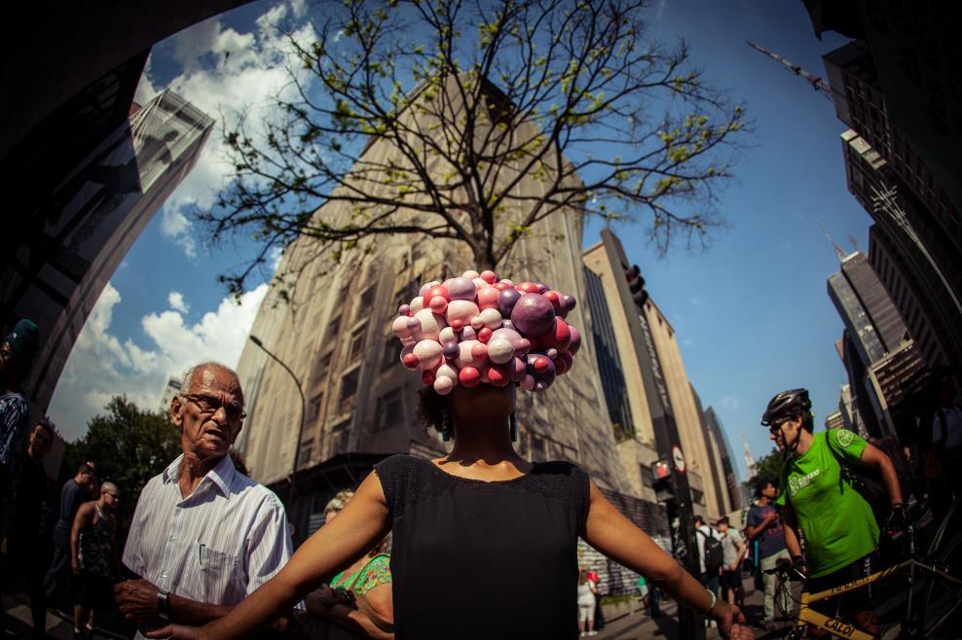

Brief: Connecting Cities through Arts and International Creative Exchange
Work with British Council teams to shape a powerful and coherent global Arts + Cities offer
British Council objectives:
- Build and strengthen international city-to-city relationships through exchange and partnerships, projects and forums to support growth, share expertise and showcase culture
- Support exciting art and artists and create long-term impact
- Demonstrate thought leadership
- Engage wider audiences
- Leverage partnership and sponsorship opportunities
- Help develop the cultural ecosystem in international cities
- Bring value to the UK

Context:
British Council is the UK’s cultural relations organisation and has long supported artists, creative experiences and the exploration of urban issues in cities all over the world. As the number of people living in cities increases and they become more powerful politically, economically and culturally, we want to strengthen our global offer for our collaborators and audiences; to demonstrate the power of arts and creative exchange in making cities dynamic, connected, inclusive and fit for the future. As a lively international debate grows around public art, civic design and agendas such as liveable cities, open cities, creative cities, we will develop a clear and compelling position which can add value to others.
Building on our current experience and portfolio, we would like someone (or a group) to work with our teams to shape our strategy, prototype some new approaches and recommend some options for programming that contribute to the British Council Arts Vision.
Proposed deliverables:
- Gain swift understanding of existing relevant British Council work - what was most impactful and why and where could they be connected for greater impact.
- Develop a coherent and powerful narrative that clarifies the objectives of a dynamic Arts and Cities programme (as opposed to our Arts work that happens in cities) with reference to existing strategies and priorities.
- Analyse positioning alongside other relevant agencies and initiatives – what is the unique value British Council can bring to its audiences and stakeholders and where can it contribute to other agendas in both the arts and cities sectors including policymakers and other influencers. Advise on the best partnerships to pursue.
- Research and present 5-10 initiatives in UK that successfully use arts, technology and creative experiences to engage and connect citizens, arts and creative practice and contribute to making cities more open, diverse and liveable. Include critical analysis of success factors, challenges, pre-existing criteria and external motivations – in terms of policymakers, institutions, industry, artists and citizens.
- Organise and contribute to a workshop process with a select group of British Council colleagues and others to collectively explore which aspects of these UK initiatives could be internationalised in three pilot cities overseas to enrich lives and contribute to systemic urban development. Work with experienced creative strategic facilitator(s) to generate new ideas and prototypes for more effective, collective ways of working.
- Make recommendations for future programming based on the prototypes developed in the workshop and through discussions.
- Prepare the findings and outcomes of this process in an effective visual way to be shared with other internal staff and potential collaborators and sponsors (not a lengthy report!) to serve as a roadmap for future work.
- Identify steps for communicating Arts + the Cities programmes

What will have changed as a result of your work?
- British Council will have a clear, compelling and focused offer which is understood and owned by staff in at least three pilot cities (overseas) and involve at least five UK partners.
- The proposed programme will reflect the best of UK’s diverse contemporary creative practice. It will respond to some of the specific challenges and opportunities of modern cities and contribute to making them more inclusive and participatory. It will consider how to use technology in the most effective way.
- There will be a clear narrative and sustainable plan for partnership proposals and internal and external stakeholder engagement.
- At least three UK cities are engaged at multiple levels for long-term international engagement
- Learnings from this process will have been embedded in the organisation

Person Specifications
- Excellent understanding of cities, contemporary urban issues, creative practice and art in the public realm, including new technologies
- Demonstrable experience in developing cultural programmes and partnerships, across different contemporary creative practice and cultural forms,
- Understanding of the international cultural landscape
- Ability to take complex ideas and multiple agendas and shape them into a clear and focused strategy
- Experience of galvanising and inspiring cross-function teams
- Awareness of the key players in the Arts and Cities sectors
We welcome applications from both individuals and organisations.
We are committed to building a culturally diverse workforce. We welcome applications from people of all backgrounds but particularly welcome applications from BAME candidates as they are under-represented within our staff team.

Indicative Timeline
15 February: Initial brief issued
18 March: Responses received
23 March: Decision communicated and contracts started
April: First findings delivered
May: Workshop
June: Final work signed off

Budget:
We have a budget of £12-14,000 for this project, inclusive of everything. We do not anticipate that international travel will be necessary at this stage.

Response:
Please provide an expression of interest with an indicative budget, outlining your approach and relevant experience and expertise of no more than 10 pages in PDF format by 18th March to emma.boulton@britishcouncil.org
Contact:

Beatrice Pembroke
Director Creative Economy
Beatrice.pembroke@britishcouncil.org
07540330036

Further information:

How does British Council Arts currently work in cities?

- Public realm work: arts productions/events/engagement in physical city spaces and the new digital realm which allow us to reach new audiences.
- Urban content: cultural professionals engaging with urban issues e.g. Playable City
- Whole city approach/ ‘creatorHoods’: we identify a target city/neighbourhood and then engage with different stakeholders and audiences in a holistic and long-term approach e.g. Seoul city project
- UK connections: twinning with UK cities, internationalising the UK approaches, UK Stakeholder engagement e.g. Venice Biennale, Hull City of Culture.
- New city leadership: engaging influential city leaders across the world with the latest cultural trends and policies with one another e.g. Going Global, Cultural Olympiads.

You can find out more about our work here: https://www.britishcouncil.org/arts

What are the special social and cultural challenges presented by cities?
- Challenges to social cohesion caused by highly visible inequalities.
- Fragmentation of communities caused by immigration.
- Concentration of youth unemployment and skills gap.
- Urban planning failures.
- High proportion of health and mental health issues.

Cities also create special opportunities for our Arts work making it easier to achieve high impact for face-to-face showcasing and capacity building.
- Volume of potential audience in different target groups
- Concentration of communities
- Public spaces (and transport systems) with large amounts of through traffic
- Strong infrastructure of Arts Organisations to partner with
- Strong social media presence
- Cities lend themselves to cross-artform programmes
- Ability
- Dynamic: attract + generate talent, ideas, new tech

